A000-AM,C-Taino-Cohoba Spoon-Manatee Bone-1000 CE

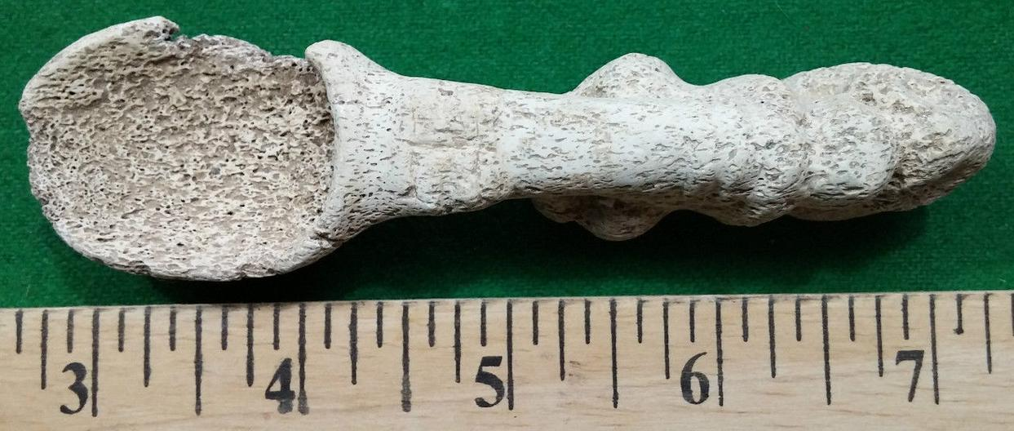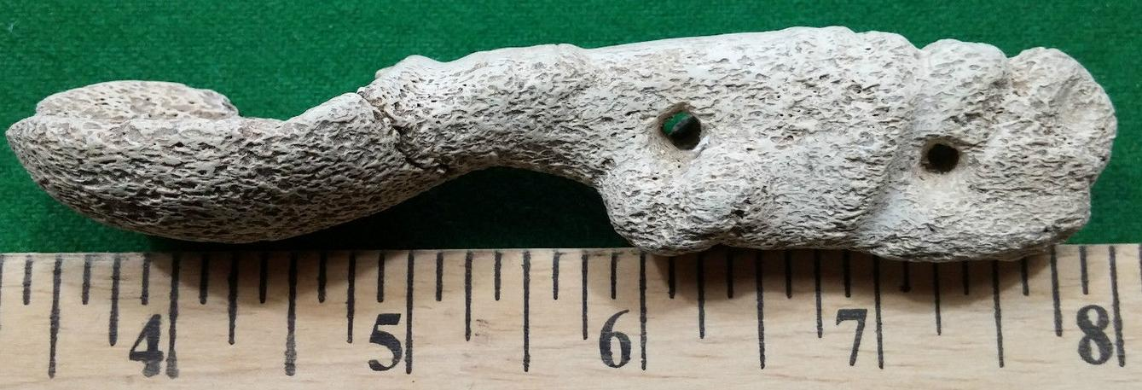

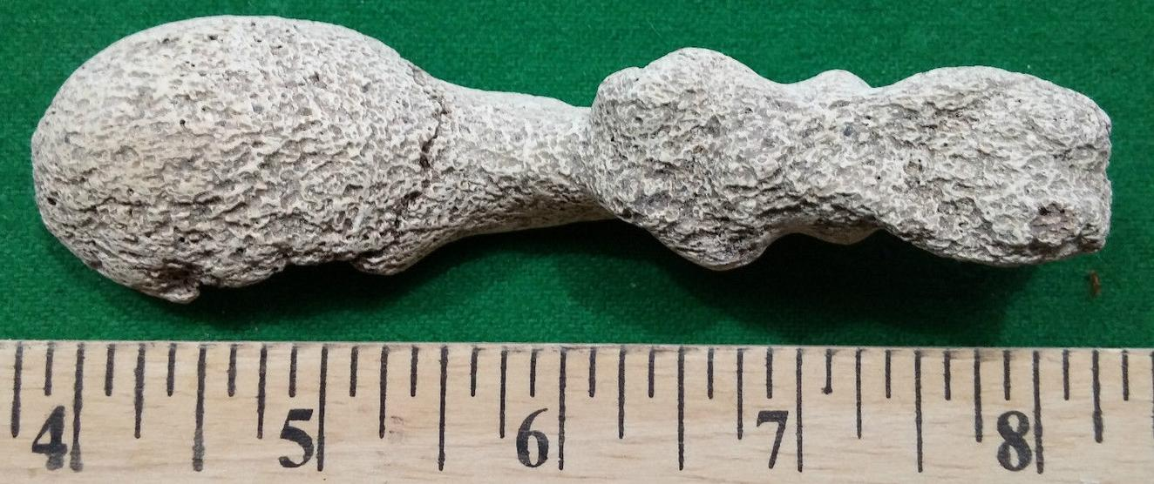

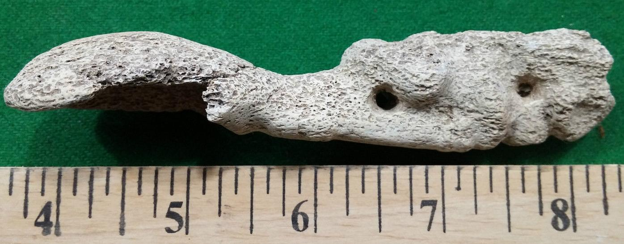

AM,C-Taino-Cohoba Spoon-Manatee Bone-1000 CE

Case No.: 18

**Accession No.**

**Formal Label:** AM,C-Taino-Cohoba Spoon-Manatee Bone-1000 CE

**Display Description:**

**Cohoba spoons are very rare since they were utilitarian objects used in daily rituals.**

**LC Classification:**

**Date or Time Horizon:**

**Geographical Area:**

**Map:**

**GPS coordinates:**

**Cultural Affiliation: Taino**

**Medium:** manatee bone

**Dimensions:** 4 5/8 in. long,

**Weight:**

**Condition: original**

**Provenance:**

**Discussion:**

**References:**